**Cordtravel full setup on ubuntu 18.04 for quick setup**

--------------------------------------------------------------------

**1.Install cassandra driver for php & dependencies**

**ubuntu 18.04**

**a.Install php 7.1**

**sudo apt-get update**

**sudo apt-get install -y software-properties-common**

**sudo add-apt-repository ppa:ondrej/php**

**sudo apt-get update**

**sudo apt-get install -y php7.1**

**Php will automatically install apache also.so stop the service before openresty installation**

**b.install dependencies for php cassandra driver**

**sudo apt-get install -y g++ git make cmake clang libssl-dev libgmp-dev php7.1-cgi php7.1-fpm php7.1-dev openssl libpcre3-dev**

**c.Download cassandra drivers and libuv dependencies**

**reference :**[**https://github.com/datastax/cpp-driver**](https://github.com/datastax/cpp-driver)

**main link :** [**https://downloads.datastax.com/cpp-driver/ubuntu/**](https://downloads.datastax.com/cpp-driver/ubuntu/)

**wget http://downloads.datastax.com/cpp-driver/ubuntu/18.04/dependencies/libuv/v1.23.0/libuv1-dev_1.23.0-1_amd64.deb**

**wget http://downloads.datastax.com/cpp-driver/ubuntu/18.04/dependencies/libuv/v1.23.0/libuv1_1.23.0-1_amd64.deb**

**wget http://downloads.datastax.com/cpp-driver/ubuntu/18.04/cassandra/v2.10.0/cassandra-cpp-driver-dev_2.10.0-1_amd64.deb**

**wget http://downloads.datastax.com/cpp-driver/ubuntu/18.04/cassandra/v2.10.0/cassandra-cpp-driver_2.10.0-1_amd64.deb**

**d.install the downloaded 4 packages**

**sudo dpkg -i libuv1_1.23.0-1_amd64.deb libuv1-dev_1.23.0-1_amd64.deb cassandra-cpp-driver_2.10.0-1_amd64.deb cassandra-cpp-driver-dev_2.10.0-1_amd64.deb**

**e.Install for build php driver & extension**

**reference :** [**https://docs.datastax.com/en/developer/php-driver/1.3/building/**](https://docs.datastax.com/en/developer/php-driver/1.3/building/)

[**git clone https://github.com/datastax/php-driver.git**](https://github.com/datastax/php-driver.git)

**cd php-driver/ext**

**phpize**

**./configure**

**sudo make**

**sudo make install**

**to confirm extension is loaded go to cd /usr/lib/php/20131226/ and you can see cassandra.so**

**ADD extension=cassandra.so at the end of the file**

**Open nano editor --> press Ctrl+W, Ctrl+V to get the last line of the file**

**1./etc/php/7.1/cli/php.ini**

**2./etc/php/7.1/fpm/php.ini at the end of the file and save .**

**check cassandra module status:**

**php -i | grep -A 10 "^cassandra$"**  **or**

**php -m**

**Install openresty 1.15 from source**

**-------------------------------------------------------**

**reference :** [**https://www.digitalocean.com/community/tutorials/how-to-use-the-openresty-web-framework-for-nginx-on-ubuntu-16-04**](https://www.digitalocean.com/community/tutorials/how-to-use-the-openresty-web-framework-for-nginx-on-ubuntu-16-04)

**Install necessary packages for openresty**

**-----------------------------------------**

**sudo apt-get install build-essential unzip**

**sudo apt-get install -y libreadline-dev libncurses5-dev libpcre3-dev libssl-dev perl**

**sudo apt install -y zlib1g-dev zlib1g**

**-----------------------------------------**

**wget https://openresty.org/download/**[**openresty-1.13.6.2.tar.gz**](https://openresty.org/download/openresty-1.13.6.2.tar.gz)

**tar -xvf openresty-1.13.6.2.tar.gz**

**cd openresty-1.13.6.2/**

**./configure -j2**

**make -j2**

**sudo make install**

**----------------------------------**

**start openresty service**

**------------------------**

**Note:Since php7.1 will install apache2,you can see apache2 is already running on port 80.It is better to stop the apache2 service and completely uninstall before starting openresty.**

**sudo service apache2 stop**

**whereis apache2**

**sudo rm -rf /usr/sbin/apache2 /usr/lib/apache2 /etc/apache2 /usr/share/apache2 /usr/share/man/man8/apache2.8.gz**

**start openresty:**

**sudo /usr/local/openresty/bin/openresty**

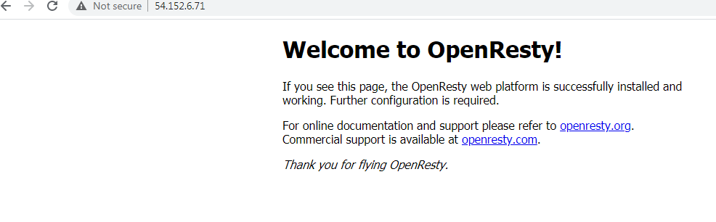

**stop the OpenResty server:**

**sudo /usr/local/openresty/bin/openresty -s quit**

**sudo nano /etc/systemd/system/openresty.service**

**and add below contents to the file**

**# Stop dance for OpenResty**

**# A modification of the Nginx systemd script**

**# =======================**

**#**

**# ExecStop sends SIGSTOP (graceful stop) to the Nginx process.**

**# If, after 5s (--retry QUIT/5) OpenResty is still running, systemd takes control**

**# and sends SIGTERM (fast shutdown) to the main process.**

**# After another 5s (TimeoutStopSec=5), and if OpenResty is alive, systemd sends**

**# SIGKILL to all the remaining processes in the process group (KillMode=mixed).**

**#**

**# Nginx signals reference doc:**

**# http://nginx.org/en/docs/control.html**

**#**

**[Unit]**

**Description=A dynamic web platform based on Nginx and LuaJIT.**

**After=network.target**

**[Service]**

**Type=forking**

**PIDFile=/usr/local/openresty/nginx/logs/nginx.pid**

**ExecStartPre=/usr/local/openresty/bin/openresty -t -q -g 'daemon on; master_process on;'**

**ExecStart=/usr/local/openresty/bin/openresty -g 'daemon on; master_process on;'**

**ExecReload=/usr/local/openresty/bin/openresty -g 'daemon on; master_process on;' -s reload**

**ExecStop=-/sbin/start-stop-daemon --quiet --stop --retry QUIT/5 --pidfile /usr/local/openresty/nginx/logs/nginx.pid**

**TimeoutStopSec=5**

**KillMode=mixed**

**[Install]**

**WantedBy=multi-user.target**

**Install lua version 5.1 only**

---------------------------------------

reference : <https://github.com/luarocks/luarocks/wiki/installation-instructions-for-unix>

**sudo apt install -y build-essential libreadline-dev unzip curl**

**curl -R -O http://www.lua.org/ftp/l**[**ua-5.1.5.tar.gz**](http://www.lua.org/ftp/lua-5.1.5.tar.gz)

**tar -zxf l**[**ua-5.1.5.tar.gz**](http://www.lua.org/ftp/lua-5.1.5.tar.gz)

**cd lua-5.1.5**

**make linux test**

**sudo make install**

**------------------------------------------------**

**Install luarocks**

**---------------------------------------------------**

**wget https://luarocks.org/releases/luarocks-3.3.1.tar.gz**

**tar zxpf luarocks-3.3.1.tar.gz**

**cd luarocks-3.3.1**

**./configure --with-lua-include=/usr/local/include**

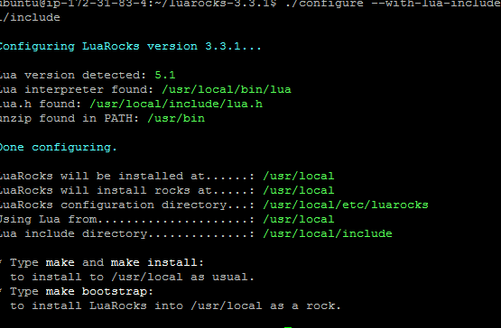

**make**

**sudo make install**

**-----------------------------------------------------**

**Install lua-cassandra module**

**-----------------------------------**

**This command must run on the home directory ,note within luarocks**

**sudo luarocks install lua-cassandra**

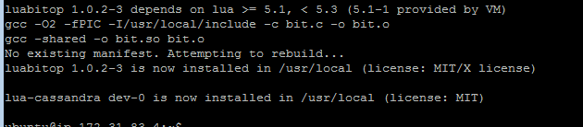

**additional changes & files added**

**1.replaced default nginx.conf file from our custom one and edited username as ubuntu**

**2.copied cassandra_manager.lua,servers.lua from our local /usr/local/openresty/lualib folder**

**3.created sites.d folder under nginx folder and created custom file named rajeshlocal.download (custom file ,only changed the location of public folder )**

**4.Found latest openrsty version is giving error.so installed** [**openresty-1.13.6.2.tar.gz**](https://openresty.org/download/openresty-1.13.6.2.tar.gz) **15 & 17 not compatible**

**Start fpm & openresty**

**---------------------**

**sudo service php7.1-fpm restart**

**sudo systemctl start openresty**

**sudo systemctl status openresty**

**check they are running properly:**

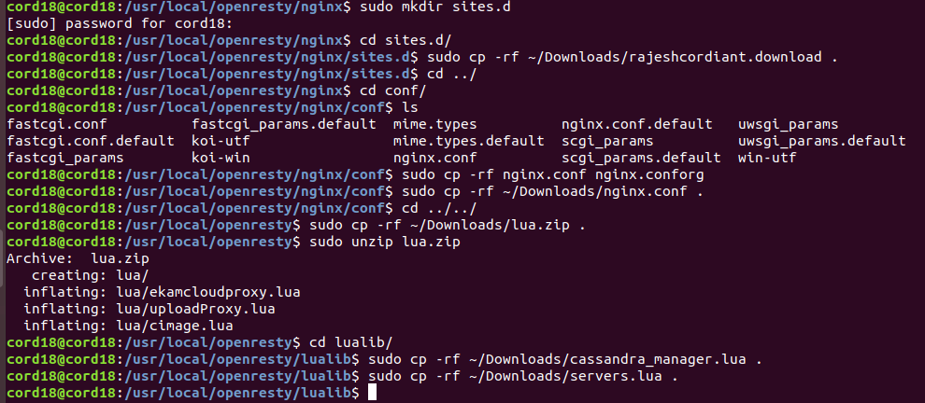

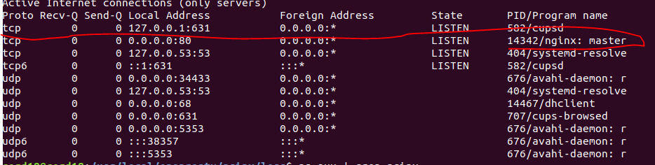

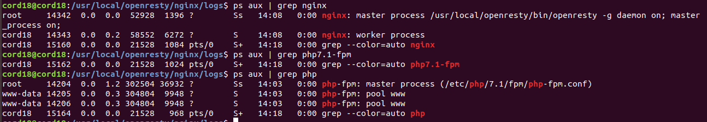

**Installation setup**

**------------------**

**php7.1**

**Lua 5.1.5**

**luarocks-3.3.1**

**openresty-1.13.6.2/build/nginx-1.13.6**

**luajit-2.1.0-beta3**

**php cassandra driver: php-driver/1.3**

**cassandra driver : v2.10.0**

**libuv1-dev_1.23.0-1**